# Font Pairings

**Playfair Display (header) + Lora (body)**

Playfair Display: elegant serif with high contrast—great for names.

Lora: elegant serif ideal for readability.

**Great Vibes (header) + Montserrat (body)**

Great Vibes: graceful script with romantic flair.

Montserrat: clean modern sans-serif for clarity.

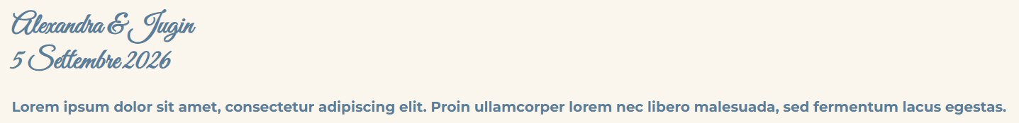

**Cinzel Decorative (header) + EB Garamond (body)**

Cinzel Decorative: classic, slightly ornate, regal.

EB Garamond: refined serif for body text.

**Montserrat Alternates (header) + Open Sans (body)**

Montserrat Alternates: distinctive geometric headings.

Open Sans: neutral, versatile, very readable.

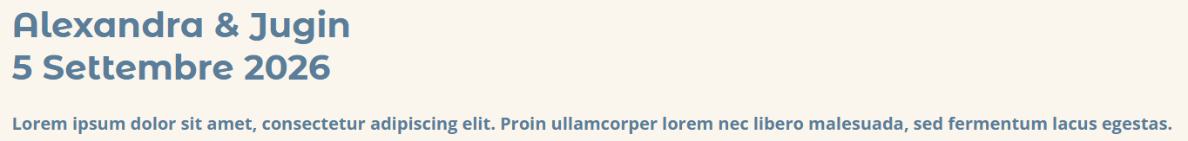

**Dancing Script (header) + Raleway (body)**

Dancing Script: lively and personal.

Raleway: elegant sans-serif to support it.

